LEARNING WALK NORM:
The purpose of the learning walk is to provide opportunities for teachers to reflect on their own instructional practice and to improve on their practice.
- PROFESSIONAL
I understand that I will be walking into another teacher’s classroom and will need to adhere to the etiquettes of each classroom. I also understand that as a professional I am using this observation as a way to improve my teaching practice and plan for pedagogical change.

- CONFIDENTIAL
I understand that the observation of teachers whether good or bad is confidential and will not be talked about outside of the learning walk forums/discussions. Rather, the discussion is on the teaching practice itself.

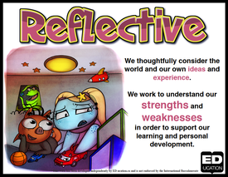
- REFLECTIVE
I understand that this process is reflective on my instructional practice. It is a tool for which observation and discussion of effective instruction are used to improve my teaching practice.

- NON-EVALUATIVE & NON-JUDGEMENTAL
I understand that this will not be used for evaluation purposes nor will it be used to judge others teaching. It is a tool to refine my instructional practice and get collegial support while doing it.
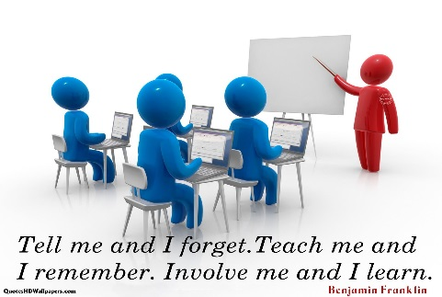
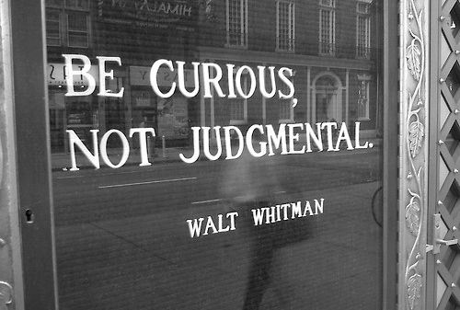

Learning Walks Quick Guide
Guide to the STAR Reflection Process

Always be clear that we are conducting a Learning walk so we can learn to reflect on our own practices.

OBSERVATION | REFLECTION | DEBRIEF | MODELING
Try to make eye contact when entering the room. Smile | Find a good location | “How could the focus indicators show up more in my classroom?” | Remain calm and smile.
Find a good location from which to observe without disrupting the class. | Start in trios/pairs | “What can I apply to my own classroom?” | Share your own learning.
Say (or mouth) “Thank You” as you are leaving the room. | ‘What did I see?” | “What instructional habits will I commit to?” | Share your commitment(s).

THE DEBRIEF PROCESS:

- What did I see?
- What are some examples?
- Where would we mark this on the continuum?
- How could the focus indicators show up more in my classroom?
- What can I apply to my own classroom?

PITFALLS TO AVOID:
- Do not start the debrief as a PLC group.
- Avoid judgement comments: “Wow that was a great class!”
- Avoid using the term should: “What should they have done differently?”
- Do not score the teacher, mark the continuum: “I score him low on this…”

