Exit Pass Faculty Meeting September 19, 2017

Name: ___________________________________ Department: ______________
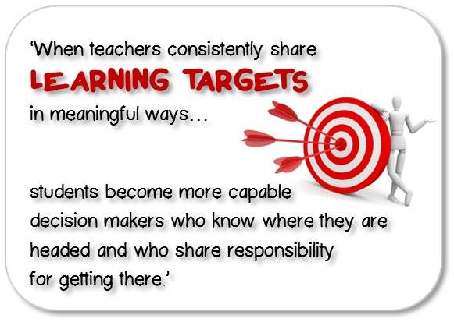
- Describe for students, in language students can understand, exactly what they’re going to learn by the end of the day’s lesson.

- Describe the performance or demonstration of understanding –what students will do, make, say or write during the lesson as evidence of how well they are progressing towards mastery of the learning target.

Additional Questions, Concerns, or Recommendations:

