Lesson Title: Understanding the Moanalua High School Success Standards

Objectives:
- To understand the three Moanalua High School Success Standards
- To understand the importance of learning and using these standards
- To be able to see practical applications of the Success Standards in real life experiences
- To review how to use the Tree Map (Thinking Map)

Materials Needed:
- Moanalua High School Success Standards: Information Sheet
- MoHS Success Standards Student Worksheet

Instructions:
- Pass out the Moanalua High School Success Standards Information Sheet and discuss the information there with students
- Share your own examples with them as you discuss the three success standards and how you use them in your classroom…in your life.
- Pass out the student MoHS Success Standards Student worksheet – tree map (Thinking Map). Tell students that that the Tree Map is used for grouping and organizing information (e.g. main ideas, supporting ideas, details).
- Explain how to use the Tree Map: (you may draw on the board or use Tree Map examples below)
- 1st Row -Top Line: Main Idea
- 2nd Row – List 3 Supporting Ideas
- 3rd Row - List all the details under each of the 3 Supporting Ideas
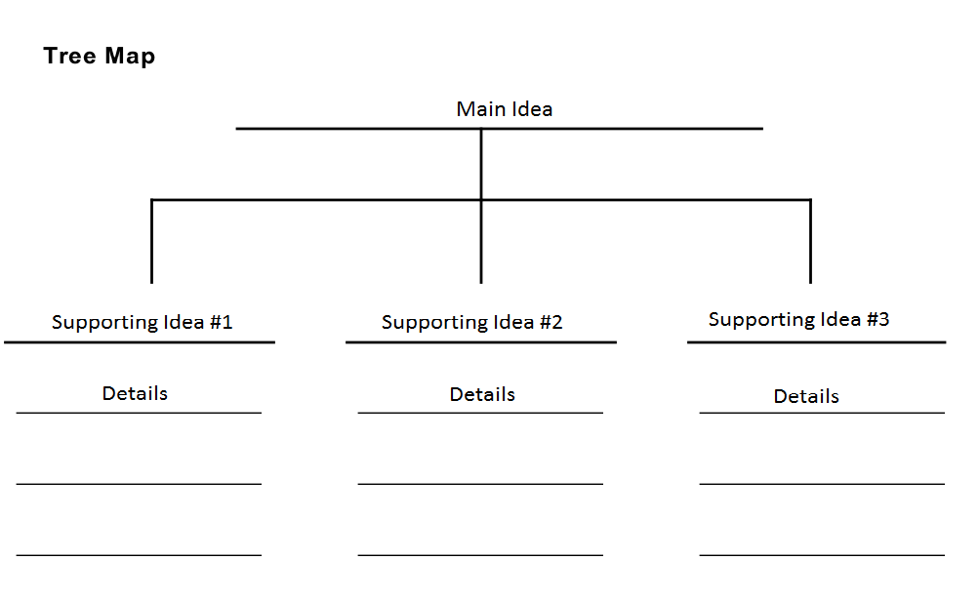

- Have the students use the Moanalua High School Success Standards Information sheet as a resource and organize the information using the tree map. ?? do you want to give them the label for the “main idead” i.e. Success Standards?

Suggested Reflection Questions:
- How do the MoHS Success Standards relate to decision-making?
- What are some “big” decisions you will need to make in the near future?
- What can you do to prepare yourself to be a good decision maker?

(Turn over for Answer Key)
